**Product Design**

|  |  |
| --- | --- |
| **Team** | **Coding Warriors**  Laurel Igiehon, Uriel Moreno, Sebastian Lopez, Aashishpal Reddy Kandala, Vincel Novelo |

|  |  |  |  |
| --- | --- | --- | --- |
| **Revision Number** | **Revision Date** | **Summary of Changes** | **Author(s)** |
| 1.0 | 10/08/2025 | Included information architecture diagram and design summary | Laurel Igiehon |
|  |  |  |  |
|  |  |  |  |

# Class Diagram(s)

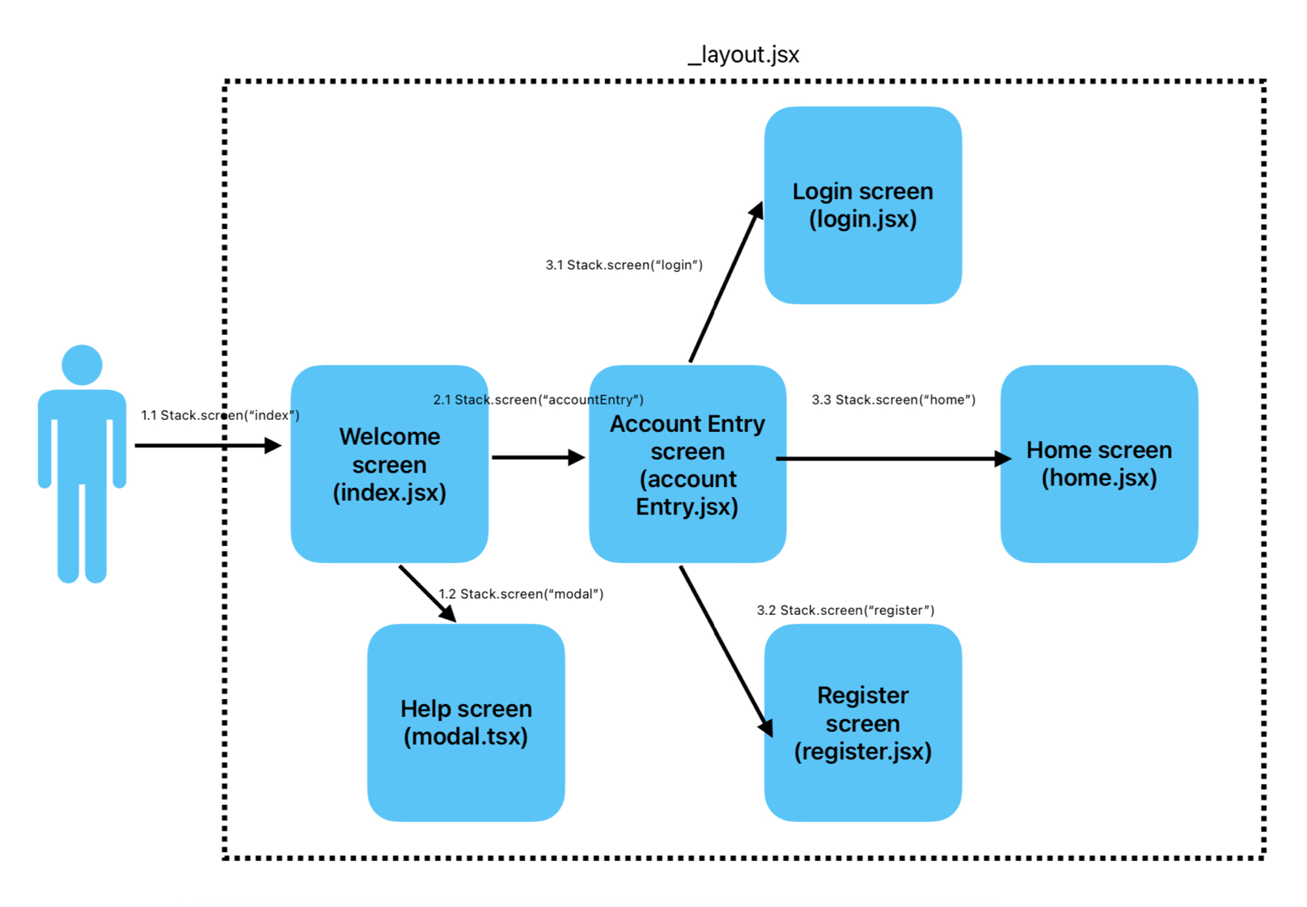

# ER Diagram(s)

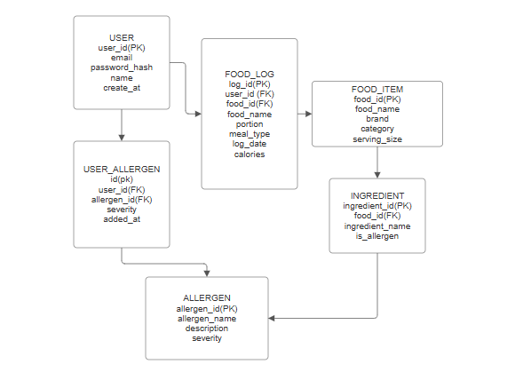

# Information Architecture Diagram

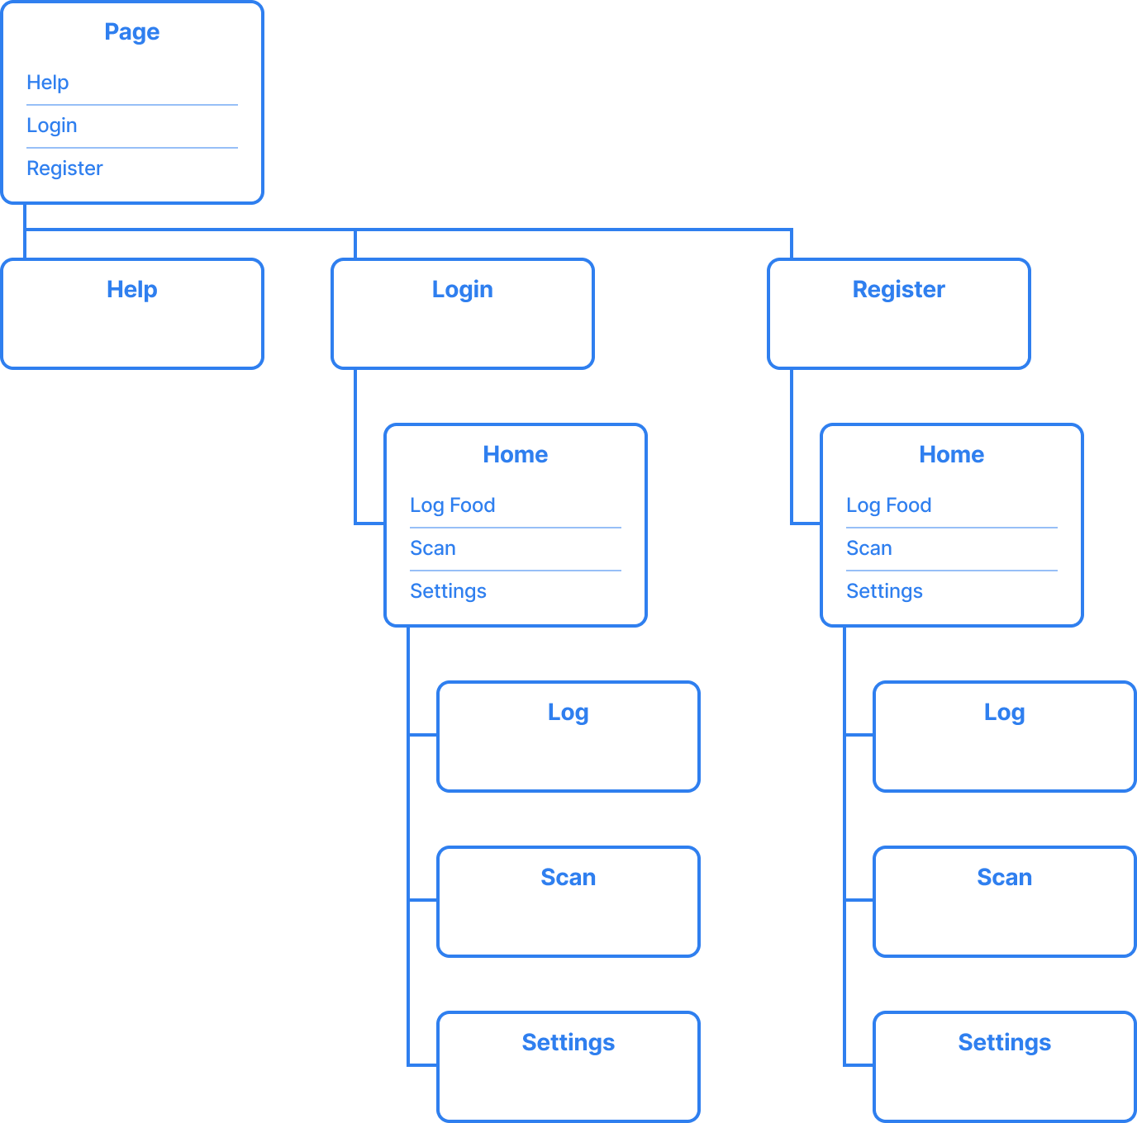

# User Interface Wireframe(s)/Screenshot(s)

|  |  |  |
| --- | --- | --- |
| Welcome screen  (index.jsx) | This screen is the first screen the users see’ when interacting with the Food Log app. They can use the “Continue to Login” button to proceed to the account entry screen, or access information about how to use the app using the “Help” button. |  |
| Help screen  (modal.tsx) | The help screen is displayed when interacted with the “Help” button on the home screen. It tells the user information about how to navigate and use the app. It can be closed by using the “Close” button. |  |
| Account entry screen  (accountEntry.jsx) | The user can interact with two buttons, the “Login” and “Register” option. This brings them to the Login and Register screen, respectively. |  |
| Login screen  (login.jsx) | If the user already has an account, they can enter their credentials to login to the app. They will proceed to the Home screen.  (Currently, the app does not keep track of accounts or check if any input is a valid email and password. This will be implemented later.) |  |
| Register screen  (register.jsx) | If the user wants to create a new account, they can enter the necessary information to create one. Once submitted, the user will be brought to the Home screen.  (Currently, the app does not keep track of accounts or check if any input is a valid email and password. This will be implemented later.) |  |
| Home screen  (home.jsx) | The current Home screen is empty. We plan to have different, interactable buttons and features for the user to use. These will allow them to view or add new food logs, track current logs, view log history, etc. |  |

# Design Summary

Our design shows our intended placement for screens and future features. We intend to have a minimalistic approach towards the app’s design, especially for its first iterations. We want to focus more on implementing the features before revisiting the UI to implement improvements for the color scheme, text layout and size, animations, etc.

# Design Rationale

Right now, we are using a simple UI design for the user authentication. We want the user to see the sign in or create an account button immediately after getting on the app. This will make signing in quicker, especially when the user wants to log new symptoms from the food they are trying. After signing in, the user should be able to see the home screen where they can immediately start logging the new symptoms. Being able to document these symptoms as quickly as possible is one of our priorities, as most people wouldn’t want to waste too much time.

Currently, there is not much we can discuss on design changes since we are still designing the UI as we progress through the project. We will let you know about the big design changes made in the next design document for Sprint 2. Since we are creating an app for both Android and iOS, we decided to use React Native. This will allow us to use a single codebase and make development easier.